9-12

ANNUAL FALL EDUCATIONAL MEETING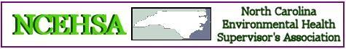

October 10-11, 2024

Hampton Inn & Suites

Aberdeen, North Carolina

# AGENDA

**Thursday, October 10**

8:30 - 10:00 **When Things Go to Pot: THC Food Investigation**

Thomas Jumalon

10:00 - 10:15 **Break**

10:15 - 12:00 **Mocktails, Potions, Elixirs: Overview of Unapproved Additives Flooding the Market**

TBA

12:00 - 1:30 **Lunch**

1:30 - 3:00 **Swimming Pool Pumps**

Terry Chappell/ Chad Gambill

3:00 - 3:15 **Break**

3:15 – 5:00 **State of Environmental Health**

Jon Fowlkes, Deputy Section Chief, NCDHHS

**Friday, October 11**

8:30 – 12:00 **NCEHSA Business Meeting**